GATEWAY ISLAND (GWI): A NEW PLAYER'S GUIDE
SPOILER WARNING: This guide is full of spoilers. It works as a step-by-step walkthrough of Gateway Island. If you'd like to discover the island yourself, explore first and come back here only if you get stuck.
Welcome to MagicDuel! Every new character starts on Gateway Island (GWI). It teaches gathering, crafting, creatures, and getting around before you reach the mainland.
The island is quiet and gives few hints. This guide walks you through it in a sensible order. It is based on a full walkthrough in October 2026.

Quick Start: Your First 10 Steps
1. Read every sign first. Signs hold hints and sometimes secret tips. Some tips only work if you follow them before picking things up.
2. Collect Reality Shards. Click the orange items you find around the island. Look out for spirit scraps too.
3. Make the map at Guardian's Esplanade. Use your Reality Shards in the Map Maker. The sign says it's on the right, but it's on the left.
4. Grab the Old Mattock and mine stone. Mining at the Esplanade is free. You need at least 10 Stone and 1 Crystal.
5. Make the Aramor Fenth. At Aramor's Arisal, load 10 Stone, 1 Reality Shard and 1 Crystal into the Assembler. This unlocks more of the island.
6. Take the rain collector, not the shovel. The Survivor's Junction sign tells you to. Then go back to the Dock (Castaway's Landing) for a reward. Do this before picking up any shovel.
7. Get the free tools in Experimental Grotto. An Old Resin Collector and an Old Bark Knife are waiting there.
8. Use the Empty Barrel. It raises your max AP by 5.
9. Climb to Gateway Plateau. Pick up the frayed rope at the top.
10. Choose your Principle carefully. The scroll basket on Gateway Mountain Trail gives a permanent +1 to a Principle. Decide before you click.

Scene By Scene
Hover over an exit arrow to see where it goes and what it costs. Most short moves cost about 1 AP. Some cost 14 to 18 AP.

Castaway's Landing (the Dock)
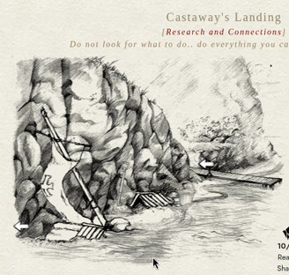
What's there: This is where you arrive. The game calls it the Dock, but no sign says so. Free old tools lie around, including a shovel.
What to do: Read everything. Hold off on the shovel until you've read the Survivor's Junction sign.
Exits: Up to Guardian's Esplanade (about 1 AP). Two arrows here look alike, but one costs 15 AP. Hover before you click.
Tip: Leave anything labelled as a staff or reset tool alone.

Guardian's Esplanade
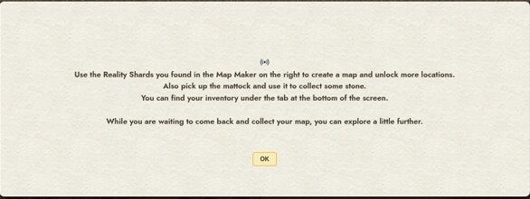
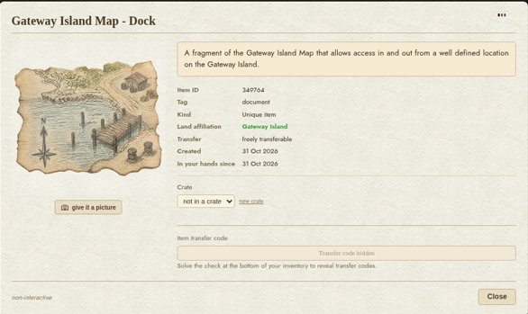
What's there: The sign, the Map Maker (on the left), an Old Mattock, and Memory Stones.
What to do: Make your map with Reality Shards. Take the mattock and mine. Mining costs no AP and recharges in about 30 seconds. Each swing gives a random Stone, Crystal or Pebble, plus gravel.
Exits: Up to Aramor's Arisal and down to Castaway's Landing (about 1 AP each).
Tip: The stone counter on screen may not update. Keep mining until you're sure you have 10.

Aramor's Arisal
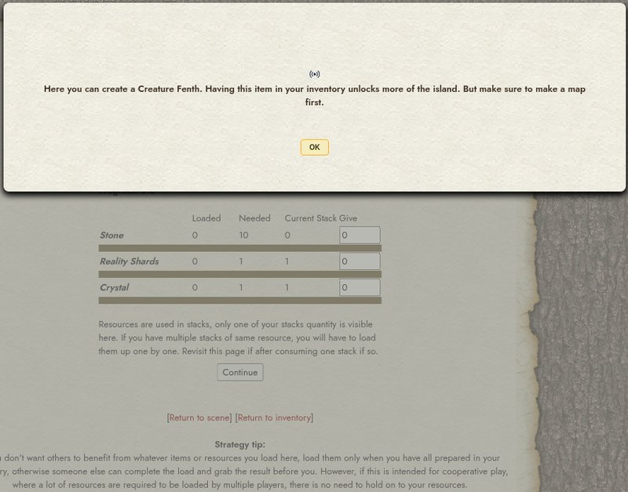

What's there: The statue is the Aramor Assembler. There are also herbs, bark, resin, lumber, rum barrels, a scarecrow and a tattered basket. You can find an Old Axe and Old Basket nearby.
What to do: Load 10 Stone, 1 Reality Shard and 1 Crystal. Press Continue, then gather the result to get an Aramor Fenth (a creature capsule). The Assembler's "Current Stack" is the most reliable count.
Exits: Making the Fenth opens a new left arrow to Knight's Descent (about 10 to 14 AP).
Tips: Anyone can load the Assembler, but only one player gets the result. Talk to the scarecrow. Some items here say "You do not have access to this clicky yet".

Knight's Descent
An arena "where the Bacon Knight sows dissent". Fights happen here. What you need to win is not known yet.

Survivor's Junction
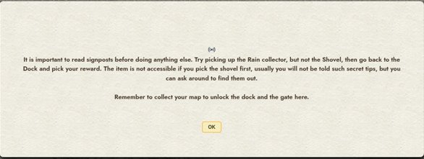
What's there: A sign with a secret tip.
What to do: Follow the tip. Take the rain collector, not the shovel, then return to the Dock for a reward.
Tip: If you already took a shovel or rain collector, the tip may not work. The rain collector can't be clicked once it's gone.

Loreweaver's Cavern
On the climb between the Junction and the Mountain Trail. Keep heading up.

Gateway Mountain Trail
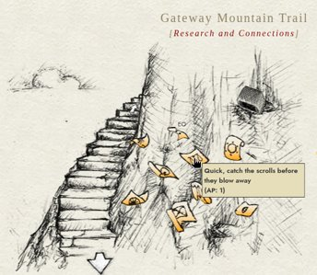
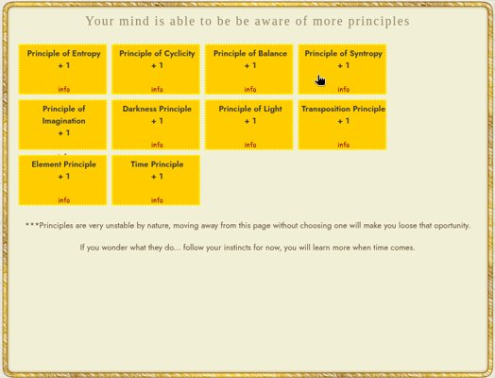
What's there: Baskets, including a scroll basket ("Catch the scrolls"), and a warning about high altitude.
What to do: Keep climbing to the Plateau.
Tip: The scroll basket looks like an ordinary exit, but it opens a one-time Principle choice. Leaving the page loses your chance. Pick on purpose. There's no confirmation, and the page keeps offering the rest after you choose. Check your profile to see what you got.

Gateway Plateau
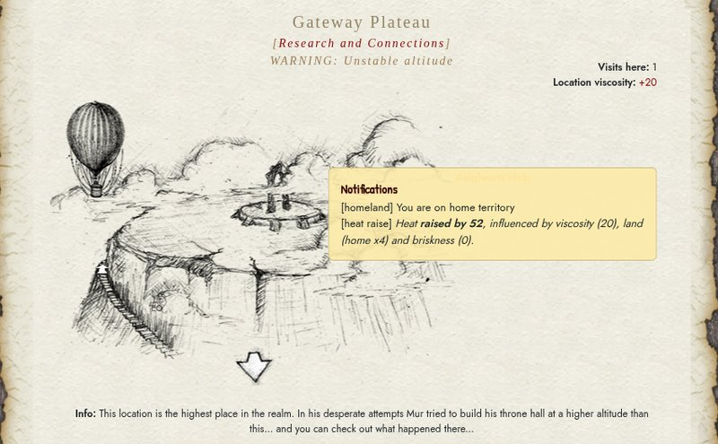
What's there: Frayed rope, the hot air balloon, and an exit to Gateway Summit (14 to 18 AP).
What to do: Collect the rope; it shows in your inventory as "Used Rope". Click the balloon to see what it needs. It says you need "an item that allows you to Fly, somehow".
Tip: Launching the balloon takes you off the island. Only do it when you're ready to leave.

Experimental Grotto
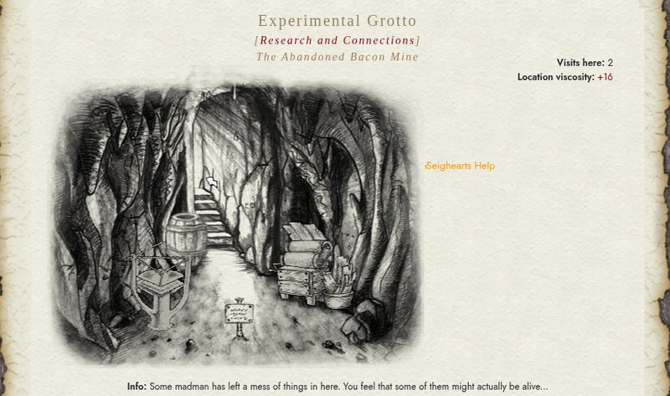
What's there: A paper workshop. A free Old Resin Collector and Old Bark Knife. A Bark Press (only for characters with 20 or fewer active days). A Paper Press. The Empty Barrel.
Recipes: Thin Wood Sheets + Water + Resin make Paper. Paper + Water + Glue make Cardboard.
Exits: About 14 AP to enter and 18 AP to leave. Plan ahead.
Tip: If the Paper Press "Return to scene" link doesn't work, reload the page.

The Obelisk
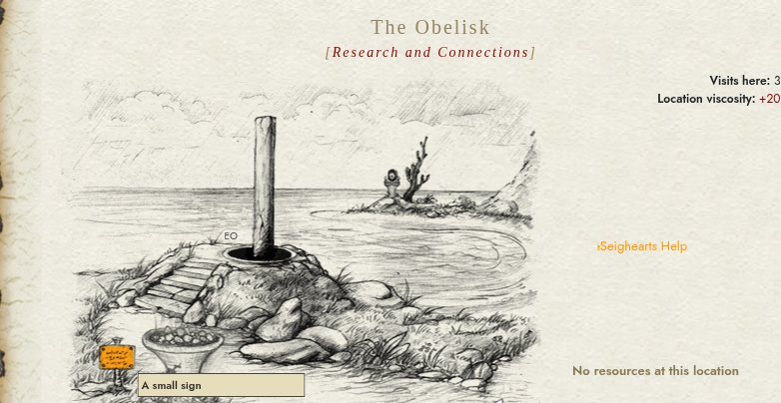
What's there: A sanctuary where Memory Stones are charged with Heat. The sign explains Heat. A pillar gives a daily item ("Used tape"). Across the water is "a distant object" you can't reach yet.
Exits: A dead end. Go back the way you came.

Loreweaver's Lock
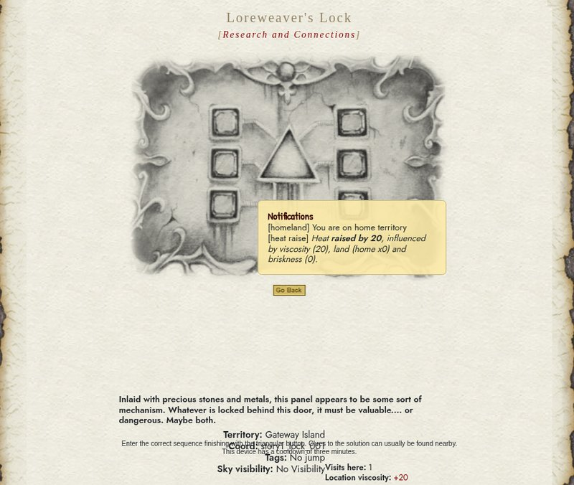
What's there: A button-sequence puzzle with a 3-minute cooldown.
Tip: Clues are in nearby scenes. Look around before you press anything. There's no clear exit, so use "Go Back".

Castaway's Cove
A fishing spot.

Riddles
Some objects ask a riddle. Read it slowly and think of everyday things. Ask the helper bot if you'd like a hint.

Things That Trip People Up
Exit labels only show on hover. Clicking an unlabelled arrow by mistake still costs AP.
AP costs can differ. The cost shown on hover may not match what you're charged. The AP display doesn't always refresh.
Locked items are invisible. You only learn something is locked when you click it.
Tools you lack aren't flagged. A resource only tells you it needs a special tool when you click it.
"Standby..." clicks. Some clickables get stuck. Reload the page.
Double clicks. The inventory and some exits need a second click, especially after a dialog closes.
Inventory filter. It can hide items such as your map. Check the filter.
Private messages need a refresh. New PMs only appear after you reload. Pick a message type before you send a reply.
Paper Press return link. It may not work. Reload to get back.
Principle page. There's no confirmation after you choose. Check your profile.
Logging out. It's hidden under the compass wheel at the top-left.

Where To Ask
MagicDuel forum
Live Help
In game: Say hello to Seighearts Help Bot, Seigheart's helper bot. It's happy to give hints, and it never asks for passwords.
Good luck, and enjoy the island!

